SUGARCANE GROWING HEALTH AND SAFETY
WE SHARE RESPONSIBILITY

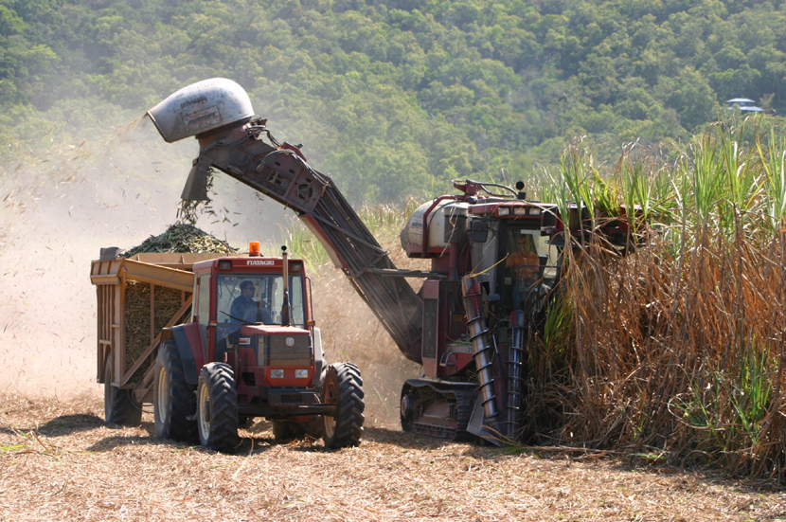

SAFETY INDUCTION INFORMATION FOR SUGARCANE FARM CONTRACTORS

Including Harvest, Haulout, Transport and Spraying Contractors

Farm: ____________________ Contractor: _______________________________

The health and safety of all the people who work and who live on this farm is the most important responsibility that we all share.

As owner/ manager, we have responsibility for the health and safety of workers and others who work on this farm. This includes contractors.

The following are the working practice arrangements that we see as important for ensuring the health and safety of workers and others on this property.

Please read this leaflet carefully, and if you do not understand any section, please ask for an explanation. As the contractor, we ask you to include this information in the information that you give to all workers in your team. Extra copies are available.

(This document has been produced to assist communication between sugarcane farm owners/ managers and contractors on agreed work practice to reduce risk of injury and illness on the farm. This document should ONLY be used where there is an active Managing Farm Safety risk control program in place on the farm. Employers are responsible for identifying and, where practicable, removing risks associated with hazardous work, mechanical hazards, fumes, noise and hazardous substances. Control measures are outlined in the Australian Centre for Agricultural Health and Safety Guidance Notes).
- REPORTING HAZARDS ON THE FARM
We have already made a check of this farm to identify hazards to workers and others, and we are working to continue to improve the working environment to prevent injury and illness.
- We ask that you report hazards that you and your workers notice to the owner/ manager, and we will welcome your suggestions for how to reduce the risk of injury and illness on this farm.

- HAZARDS ON THE FARM
Attached is a farm map. Marked on the farm map you will find hazards that we have identified, which may affect the work that you do on the farm, or may be particularly hazardous to your operation. These include:
- Powerlines
- Railway lines and headlands
- Dams, irrigation channels, Shear lines on gullies culverts, creeks, drains, steep banks and wet areas
- Chemical store
- Roads and boggy areas
- Other: ……………………………………………………………………………………..

- WORK CLOTHES
Your workers are expected to come to work dressed in suitable clothes, which do not pose a safety risk. These include:
- Suitable work boots with non-slip soles for work on the farm.
- Work overalls, long leg trousers or sensible work shorts.
- Long sleeved shirt (preferably), buttoned at the wrist, or rolled up in such a way that no loose ends can be caught in machinery or on protruding materials.
- Shirts tucked into trousers, and no loose clothing that could be caught in machinery, including corks of jackets etc.
- A wide brimmed hat for outdoors work.
- Your workers are expected to wash their work clothes after each work day, especially when working with chemicals.
- Other: ……………………………………………………………………………………..

- ACCESS TO AREAS OF THE FARM
The roads on this farm are not made to public road standards. Vehicle speed should not exceed …………………………….km/h. When driving near buildings, speed should be reduced so that you can stop instantly to avoid injury to others.
- The attached farm map outlined access roads and areas of this farm to which you and your workers will have access. Please let the owner/ manager know if any member of your team would like access to any other part of the farm, so that their safety and that of others is protected.
- During harvest, haulout routes have been established. The farm map identifies these haulout routes and where applicable, identifies train lines. Some cane fields have narrow access and headlands; these have also been identified on the map.

- EMERGENCY ARRANGEMENTS
In the case of an emergency, contact the owner/ manager and call “000” for fire brigade, ambulance or police.
- First aid kits are located
- Emergency telephone numbers are located at
- The UHF/VHF channel used on the farm is
- The bush fire brigade channel is
- Fire extinguishers are located
- Fire blankets are located
- Trained and designated first aid officer/s
- You are responsible for the provision of emergency equipment on your machinery eg fire extinguishers, where required.
- Other:

- COMMUNICATION SYSTEMS
Please supply your contact details to ……………………………………………….In case we need to contact you in an emergency situation.
If you need to contact the manager of this farm: _______________________
Name
Phone (daytime):
Phone (night time):
Phone (mobile):
Email:
The people who are available to handle any questions that you have are:
Name Position Telephone

- PROVISION AND USE OF PERSONAL PROTECTIVE EQUIPMENT (PPE) AND CLOTHING
It is your responsibility to provide protective equipment for your workers to perform their work. It is also your responsibility to ensure that your workers are dressed in appropriate work clothes and that they use protective equipment that you have provided.
The owner/ manager will inform you of the areas of the farm and livestock that the have been recently sprayed/ treated with pesticides.
It is your responsibility to provide and ensure appropriate PPE is worn by your workers if they are required to work in these recently sprayed areas. If you have any questions, please contact the farm owner/ manager.

- HYGIENE
Good personal hygiene will help to reduce the risk of illness due to infection or contamination with hazardous substances that your workers may be exposed. Your workers must:
- Ensure that they wash after working with and handling pesticides, dogs or other animals, especially before eating.
- Make sure that their work clothes are washed regularly. They will need to change clothing daily if they’re working in areas that have been sprayed with pesticides. Never re-wear unwashed clothes that have been contaminated with pesticides.
- NOT smoke inside buildings, farm vehicles or cabined machines.
- Keep up to date with their tetanus vaccinations.
- Avoid walking/ wading in stagnant water
- Not be in possession of, consume or be suffering the effects of alcohol or any illicit drug.
- Other:

- AMENITIES
The following amenities have been made available for your use and the use of your workers. The location of amenities are:
- Toilets …………………………………………………..
- Shelter/ meal sheds …………………………………………………..
- Drinking water …………………………………………………..
- Washing facilities …………………………………………………..

Arrangements have been made for the provision of amenities between everybody sharing the workplace.
Where amenities are shared by a number of different employers and workers, eg at cane rail and haulout sidings, the provision and use of amenities will be by mutual agreement by all parties.
- WORKERS COMPENSATION ARRANGMENTS*

* EITHER
You, the contractor, are responsible for workers compensation insurance for workers employed by your business. The responsibilities of employers and workers are available and displayed at:
We need to sight your current Worker Compensation Policy for you and your employees and record details.

AND/ OR
You are covered by Personal Accident Insurance. A copy of the policy is available for perusal, and the rights of workers and how to make a claim are displayed at:

* (Advice is available regarding who is responsible to manage Workers’ Compensation can be obtained from your Insurer, your State Work Health Authority, your farmer/ grower organisation or your union).

- INJURY REPORTING
We keep a farm Injury Register on this farm. We would like any injury or illness that results from your work on this farm recorded in this register. We record all injuries/ illness, whether minor or major. Injury Register forms are located:
; or contact the owner/ manager.

Note: As an employer, you have an obligation to report any injury or illness sustained by your employees to the relevant State Work Health Authority within the statutory reporting period.
- GENERAL
- If you feel that you, or your workers, do not have the resources or experience to undertake a job safely, please advise the owner/ manager, and do not proceed with the job.
- The laws of this State require that the owner/ manager provide a safe work place and safe work systems. In order to help us meet this responsibility, we ask you to tell the owner/ manager about any safety hazard or problem that you encounter.
- We ask you and your worker to cooperate with our health and safety program, and comply with our rules to protect your own safety and the safety of other workers.
- The same law requires that all workers take care to ensure the health and safety of others who are on this workplace – including other family and visitors.
- It is not acceptable for any worker to be under the influence of alcohol or other drugs during work on this farm. Any person who is affected by alcohol or drugs will be asked to stop work and leave the farm until it is clear that no-one’s safety is at risk.
- You must follow the rules at haulout and cane railway sidings. These can be obtained from the mill by contacting the mill transport officer.
- There are children living on this farm. Their safety must be a high priority. Please be careful when driving vehicles or machinery; never reverse without checking for children or other visitors.
- When working, please do not bring children with you onto this farm.
- Please do not bring dogs or pets onto this farm.
- Please do not bring unauthorised visitors onto this farm.
- DO NOT bring firearms or other weapons with you onto this farm.

- OTHER ISSUES

SPECIFIC SAFETY INDUCTION INFORMATION

SPRAYING CONTRACTORS
- Comply with State requirements for chemical application, and supply a copy of those spray records to the owner/ manager.
- Use chemical as per labelled instructions.
- Use PPE according to label instructions.
- Only use trained operators to apply pesticides.
- Report any incident relating to chemical use, eg spills, and injury
- Have labels and MSDSs available for all chemicals that they use as part of their work.
- Use only the specified site for mixing/ loading and wash down. This site is located: ………………………………..
- Spray equipment to be calibrated and in good working condition.
- Spraying to be undertaken only in suitable weather conditions with care not to affect the surrounding environment.
- Other:

GENERAL TRANSPORT AND CARRIERS
- Drivers must contact the owner/ manager on or before arrival to receive delivery instructions.
- All drivers and operators must be wearing appropriate work boots and clothing.
- High visibility vests are to be worn at night.
- Plan and allow sufficient time to reduce fatigue when driving long distances.
- When unloading at night (or in poor light), ensure that there is adequate light for loading/ unloading.
- Ensure that trucks are fitted with reversing alarms.
- Do not climb onto the top of trucks without a fall arrest system in place.
- Other:

CANE HARVEST AND HAULOUT CONTRACTORS
- It is a requirement that all workers in your harvest and haulout teams have received proper safety induction and are trained to use equipment and machinery to perform their work.
- All drivers and operators must be wearing appropriate work boots and clothing.
- Haulout contractors must use the approved haulout route.
- Be aware of the whereabouts of other harvesters, haulout contactors, tractors, locomotives, cane inspectors, mill employees and persons work together during harvest.
- Overhead powerlines have been identified on the farm map. Be aware of powerlines, poles and stays.
- Do not elevate tipping bodies except at sidings.
- Do not exceed maximum speed limits for haulout or transport.
- Slow down when dust, fog and mist hazards create poor visibility during harvest.
- Narrow headlands are hazardous – take extra care when turning.
- Advise the mill traffic office when harvesting near railway lines.
- Follow rules at cane railway and haulout sidings. Do not park closer than 2.5m to the nearest railway line. Always stop and give way to locomotives at level crossings.
- Other:

EARTHMOVING CONTRACTORS
- Are required to have relevant licences and certification for machinery.
- Other:

CANE INSPECTORS AND MILL EMPLOYEES
- When entering a farm, contact the grower and notify them of your arrival and departure.
- Other:

The safety of people on this farm takes precedence over all other considerations

Signed: ____________________________ Date: ___ / ___ / ___
Contractor

Name: _____________________________
Print

Signed: ____________________________ Date: ___ / ___ / ___
Owner / Manager

Name: _____________________________
Print

DISCLAIMER
This document does not, in any way, excuse a person from doing all that is reasonable to ensure the health and safety of themselves and others. Legislative requirements vary between states and territories. Therefore, it is necessary to check with the relevant state or territory occupational health and safety authority for appropriate information.

- Notes:

…………………………………………………………………………………………………………………………………………………………………………………………………………………………………………………………………………………………………………………………………………………………………………………………………………………………………………………………………………………………………………………………………………………………………………………………………………………………………………………………………………………………………………………………………………………………………………………………………………………………………………………………………………………………………………………………………………………………………………………………………………………………………………………………………………………………………………………………………………………………………………………………………………………………………………………………………………………………………………………………………………………………………………………………………………………………………………………………………………………………………………………………………………………………………………………………………………………………………………………………………………………………………………………………………………………………………………………………………………………………………………………………………………………………………………………………………………………………………………………………………………………………………………………………………………………….……………………………………………………………………………………………………...………………………………………………………………………………………………….……………………………………………………………………………………………………….………………………………………………………………………………………………………………………..

