HEALTH AND SAFETY ON OUR FARM

WE SHARE RESPONSIBILITY

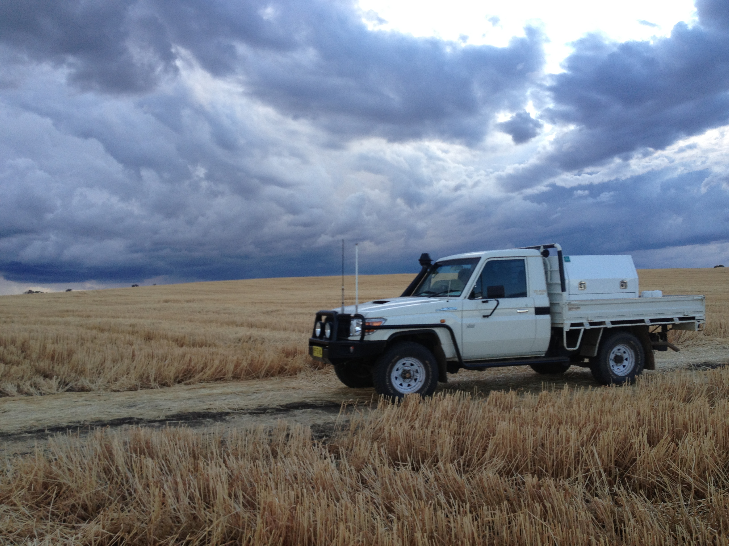

INDUCTION INFORMATION
FOR GRAIN FARM CONTRACTORS

The health and safety of all the people who work and who live on this farm is the most important responsibility that we all share.
As owner / manager, we have responsibility for the health and safety of workers and others who work on this farm. This includes contractors.
The following are the working practice arrangements that we see as important for ensuring the health and safety of workers and others on this property.
Please read this leaflet carefully, and if you do not understand any section, please ask for an explanation. As the contractor, we ask you to include this information in the information that you give to all workers in your team. Extra copies are available.

REPORTING HAZARDS ON THE FARM
We have already made a check of this farm to identify hazards to workers and others, and we are working to continue to improve the working environment to prevent injury and illness.
We ask that you report hazards that you and your workers notice to the owner/ manager, and we will welcome your suggestions for how to reduce the risk of injury/ illness.

HAZARDS ON THE FARM
Attached is a farm map. Marked on the farm map you will find hazards that we have identified, which may affect the work that you do on the farm, or may be particularly hazardous to your operation. These include:
- Powerlines
- Dams
- Wet areas
- Recently sprayed areas
- Proposed/ recent spray activity that may affect your work on this farm

ACCESS TO AREAS OF THE FARM
The tracks and roads on this farm are not made to public road standards. Vehicle speed should not exceed …………………………….km/h. When driving near buildings, reduce speed so that you can stop to avoid injury to others.
The attached farm map outlined access roads and areas of this farm to which you and your workers will have access. Please let the owner/ manager know if any member of your team would like access to any other part of the farm, so that their safety and that of others is protected.

EMERGENCY ARRANGEMENTS
In the case of an emergency, dial 000 for fire brigade, ambulance or police.
First aid kits are located
Emergency telephone numbers are located at the telephones at

The UHF/ VHF channel used on the farm is
The bush fire brigade channel is
Fire extinguishers are located
Fire blankets are located
Trained and designated first aid officer is/ are:

You are responsible for the provision of emergency equipment on your machinery eg. fire extinguishers, first aid kits where required.

COMMUNICATION
Please supply your contact details to …………………………………………………………. in case we need to contact you in an emergency situation.
If you need to contact the manager of this farm is:
(Name)

Phone (daytime):

Phone (night time):

Phone (mobile):

Fax:

Email:

The people who are available to handle any questions that you have are:
Name  ……………………………….  ……………………………….  ……………………………….  ………………………………. | Telephone  ……………………………….  ……………………………….  ……………………………….  ………………………………. | Position  ……………………………….  ……………………………….  ……………………………….  ……………………………….

WORK CLOTHES
Your workers are expected to come to work dressed in suitable clothes, which do not pose a safety risk. These include:
- Suitable work boots with non-slip soles for work on the farm.
- Work overalls, long leg trousers or sensible work shorts.
- Long sleeved shirt (preferably), buttoned at the wrist, or rolled up in such a way that no loose ends can be caught in machinery or on protruding materials.
- Shirts tucked into trousers, and no loose clothing that could be caught in machinery, including corks of jackets etc.
- A wide brimmed hat for outdoors work.
- Your workers are expected to wash their work clothes after each work day, especially when working with chemicals.

HYGEINE
Good personal hygiene will help to reduce the risk of illness due to infection or contamination with hazardous substances that your worker may be exposed to. Your workers must:
- Ensure that they wash up after working and after handling pesticides or dogs or other animals, especially before eating.
- Make sure that their work clothes are washed regularly. They will need to wash them daily if they’re working in areas that have been sprayed with pesticides. Never re-wear clothes that have been contaminated with pesticides.
- NOT smoke inside buildings, farm vehicles or cabined machines.
- Keep up to date with their tetanus vaccinations.
- Not be in possession of, consume or be suffering the effects of alcohol or any illicit drug.

PROVISION AND USE OF PERSONAL PROTECTIVE EQUIPMENT (PPE) AND CLOTHING
It is your responsibility to provide protective equipment for your workers to perform their work. It is also your responsibility to ensure that your workers are dressed in appropriate work clothes and that they use the protective equipment that you have provided for their use.
The owner / manager will inform you of the areas of the farm the have been recently sprayed with pesticide. It is your responsibility to provide appropriate PPE for your workers if they are required to work in these recently sprayed areas. If you have any questions please contact the farm owner / manager or ………………………………………………………………….

AMENITIES
The following amenities have been made available for your use and the use of your workers:

Toilets …………………………………………………..
Shelter sheds …………………………………………………..
Drinking water …………………………………………………..
Washing facilities …………………………………………………..

WORKERS COMPENSATION ARRANGMENTS*
EITHER
You, the contractor, are responsible for workers compensation insurance for the workers in your team. Please supply a Certificate of Currency from your Workers’ Compensation Insurer.
OR
Your workers are covered for workers compensation by the policy of this farm. A copy of the policy is available for perusal, and the rights of workers and how to make a claim are
displayed at …………………………………………………..........................................

* (Advice is available regarding who is responsible for workers’ compensation from your insurer, your State’s work health authority, your farmers’ organization or your union).

INJURY REPORTING
We keep a farm Injury Register on this farm and would like any injury or illness that results from your work on this farm recorded in this register. We record all injuries / illness whether minor or major. Injury Register forms are located:
…………….…………………………………………………………………………………… or contact the owner/ manager.

GENERAL
- If you feel that you, or your workers, do not have the resources or experience to undertake a job safely, please advise the owner/ manager, and do not proceed with the job.
- The laws of this state require that the owner/ manager provide a safe place of work and safe work systems. In order to help us meet this responsibility, we ask you to tell the owner / manager about any safety hazard or problem that you encounter.
- The same law requires that all workers take care to ensure the health and safety of others who are on this workplace – including other workers, family and visitors.
- We ask you and your worker to cooperate with our health and safety program, and comply with our rules to protect your own safety and the safety of others.
- It is not acceptable for any worker to be under the influence of alcohol or other drugs during work on this farm. Any who is affected by alcohol or drugs will be asked to leave the farm until it is clear that no-one’s safety is at risk.
- There are children on this farm. Their safety must be a high priority. Please be careful when driving vehicles and operating machinery, never reverse without checking for children or bystanders.
Please do not bring children on to this farm.
Please do not bring dogs on to this farm.

OTHER ISSUES

The safety of people on this farm takes precedence over all other considerations

Signed: ____________________________ Date: ___ / ___ / ___
Contractor

Name: _____________________________
Print

Signed: ____________________________ Date: ___ / ___ / ___
Owner / Manager

Name: _____________________________
Print

DISCLAIMER
This document does not, in any way, excuse a person from doing all that is reasonable to ensure the health and safety of themselves and others. Legislative requirements vary between states and territories. Therefore, it is necessary to check with the relevant state or territory occupational health and safety authority for appropriate information.

Notes:

………………………………………………………………………………………………………………………………………………………………………………………………………………………………………………………………………………………………………………………………………………………………………………………………………………………………………………………………………………………………………………………………………………………………………………………………………………………………………………………………………………………………………………………………………………………………………………………………………………………………………………………………………………………………………………………………………………………………………………………………………………………………………………………………………………………………………………………………………………………………………………………………………………………………………………………………………………………………………………………………………………………………………………………………………………………………………………………………………………………………………………………………………………………………………………………………………………………………………………………………………………………………………………………………………………………………………………………………………………………………………………………………………………………………………………………………………………………………………………………………………………………………………………………………………………………………………………………………………………………………………………………………………………………………………………………………………………………………

