HEALTH AND SAFETY

WE SHARE RESPONSIBILITY

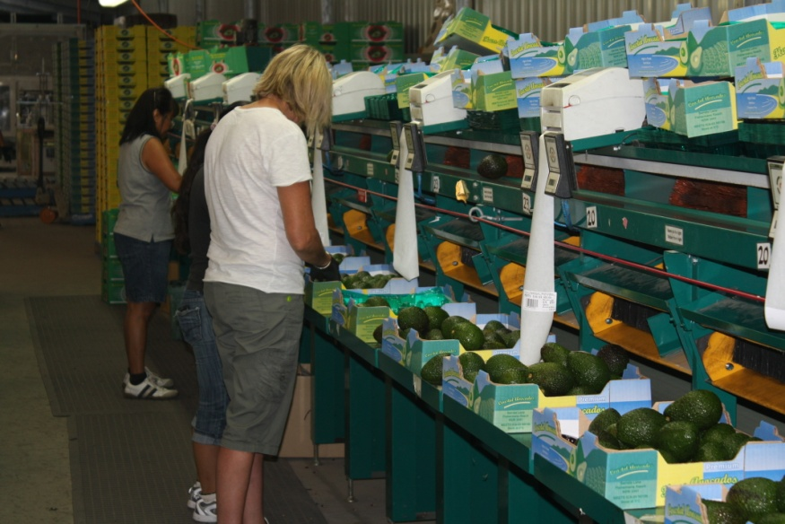

SAFETY INDUCTION

INFORMATION FOR
HORTICULTURAL PACKING SHED WORKERS

Worker:

Welcome to work on our packing shed. We hope that you find your work here interesting and rewarding. The health and safety of all the people who work and those who live on this farm is the most important responsibility that we all share.

It is important that you understand our Work Health and Safety responsibilities. We want you to also understand the commitment that we as managers of this packing shed have made to ensure your health and safety, and the health and safety of all others who may enter our place of work.

Your safety is also your responsibility. If you feel that you cannot do a job safely, don’t do it. Let your supervisor know about the problem and we will work together to fix the problem or find a safe way to complete the job.

- HAZARDS ON THE FARM AND PACKING SHED
Attached is a farm map. Marked on the farm map you will find hazards that we have identified, which may affect the work that you do on the farm, or may be particularly hazardous to your work. These include:
- Overhead Powerlines
- Dams, wet or boggy and no-go areas
- Dry Weather Only roads
- Forklift and High Traffic Areas
- Truck Loading Areas
- Packing Shed Hazards and Assembly Point

- BEING READY FOR EMERGENCIES
In the case of an emergency, assess any further danger, provide First Aid as required, and notify your supervisor or Dial Triple Zero - 000 for fire brigade, ambulance or police for further assistance.
- First Aid kits are located
- Trained and designated First Aid officer/s are:
- Emergency telephone numbers are located beside the telephones at
- The UHF/VHF channel used on the farm is
- The bush fire brigade channel is
- Fire extinguishers are located
- Fire blankets are located
- The emergency evacuation and assembly point is

- WORK CLOTHES
You are expected to come to work dressed in suitable clothes that do not pose a safety risk. These include:
- Suitable work boots/ footwear with non-slip soles for work on the farm or packing shed.
- Jeans, trousers, overalls or sensible work shorts.
- Long sleeved shirt (preferably), buttoned at the wrist, or rolled up so that no loose ends can be caught in machinery or on protruding materials.
- Shirts tucked into trousers, and no loose clothing or jewellery that could be caught in machinery, including corks of jackets etc.
- A wide brimmed hat for outdoors work.
- You are expected to wash your work clothes after each work day, especially when exposed to chemical dips and pesticide treatments.
- Other:

- ENOUGH FOOD AND WATER
It is most important to make sure that plenty of clean drinking water is available for you during the workday, especially in hot weather.
- Have a large water bottle filled with cool drinking water each day.
- Surface and dam water on the farm is NOT suitable for drinking. It may be contaminated by pesticides or animal waste.
- Drinking water is available and water bottles and can be filled at
- Worker amenities are available at

- HYGIENE
Good personal hygiene will help to reduce the risk of illness due to infection or contamination with hazardous chemicals that you may be exposed.
- Ensure that you wash after work, after handling pesticides, dogs or other animals, especially before eating.
- Make sure that your work clothes are washed regularly. You will need to wash them daily if you’re working in packing sheds where pesticides are used to treat produce. Never re-wear clothes that have not been washed and are contaminated with pesticides.
- DO NOT smoke inside buildings, farm vehicles or cabined machines.
- Keep up to date with your tetanus vaccinations.
- DO NOT be in possession of, consume or be suffering the effects of alcohol or any illicit/ illegal drug.
- Advise your manager of any known medical conditions or prescribed medications that you need to take in work time.
- Other:

- PERSONAL PROTECTIVE EQUIPMENT (PPE)
Protective clothing and equipment is provided for your protection for some work tasks. You must use these as instructed. Clean them properly after use and keep them in good order.
You must let your supervisor know if protective equipment is damaged, not available, or if you are having difficulty using the equipment provided. Protective equipment includes:
- Wearing ear muffs or plugs where loud noise is a problem.
- Wearing protective gloves when handling produce treated with pesticides or when working in contaminated areas.
- Using sunscreen when you are working outdoors in direct sunlight.

- FATIGUE
There are certain times of the year when we are very busy on this farm, especially during harvest and packing. Some horticultural and harvest operations are done at night. At these times fatigue can affect the way we work.
- Take short breaks to reduce fatigue during these busy times. Fatigue will increase the risk of accident and injury for operators of machinery as reflex times will be slowed and concentration lost.
- When working long hours, important to be alert. Ensure that you get enough sleep, and come to work fresh.
- Other:

- WORKING IN PACKING SHEDS
Packing sheds are very busy noisy places, often with many people, vehicles, forklifts and trucks working in close proximity to one another, delivering and moving produce onto pallets, into cool rooms and loading trucks.
- Ensure that guards are in place on washing, grading and packing lines before starting work.
- Check and report Emergency Stop buttons are not in easy reach or are not functioning.
- Report any mechanical or electrical hazards to your supervisor immediately.
- Packing shed floors can get wet and slippery. Report slippery areas that can be hazardous, especially around cool rooms, washing and grading lines and machinery.
- Keep floors clean of fruit and rubbish.
- Take care when moving around the packing shed. Use only designated walkways.
- Stay clear of stacked pallets and bins.
- Stay clear of fork lifts moving produce.
- Do not enter cool rooms unless you have been instructed by your supervisor.
- Other:

- MACHINERY OPERATION AND MAINTENANCE
- Do not operate any fork lift or machine unless you are properly trained, instructed and you have appropriate High Risk Work Licence.
- Before starting any machine you must complete a safety check. This includes checking the level of fuel, oil, water, transmission fluid and the condition of tyres, brakes and guards.
- You should report to the manager any malfunction or condition likely to affect the safe operation of any machine, which cannot be fixed before use. This includes guards that are damaged or missing, or where there are exposed moving parts of machinery causing a safety hazard.
- When leaving a machine with the engine running, you must ensure that equipment is disengaged, the machine is in PARK and the handbrake set.
- Whenever you remove a guard to undertake machinery maintenance, or to clear a blockage, you must replace that guard after finishing the repair and/ or before restarting the machine.
- Before working under machinery you must ensure that the machine is adequately blocked and supported.
- Keep in mind the need to be aware of the location of overhead powerlines when using and moving high machinery.
- When operating any plant, machinery and forklifts, take care of and watch for other vehicles and pedestrian traffic.
- Before starting any machine, you must undertake a safety check. This includes checking the condition/ level of fuel, oil water, transmission fluid, tyres, brakes and guards.
- Make sure that any fold down Tractor Roll-Over Protective Structures (ROPS) are erected when leaving or working outside orchard.
- Other:

- PRODUCE AND GENERAL CARRIERS
- Drivers must contact the owner/ manager on or before arrival to receive despatch or delivery instructions.
- All truck drivers and operators must be wearing appropriate work boots and clothing.
- Plan and allow sufficient time to reduce fatigue when driving long distances.
- High visibility clothing is worn at night.
- When loading or unloading produce at night, ensure that there is adequate light in the loading bay/ area for loading/ unloading.
- Ensure that trucks are fitted with audible reversing alarms.
- Do not climb onto the top of trucks without fall prevention in place.
- Fork lift operators are to be trained and have proper High Risk Work Licences for forklift truck operation.
- Other:

- SNAKES
Snakes can be found in fields and in long grass and under equipment around sheds and other cool areas. Many snakes are poisonous and many people are bitten by snakes when annoying, chasing or trying to kill snakes.
- If anyone comes across a snake, they should move away and let the snake move away. If other workers are nearby, let them know where the snake has gone.
- If bitten by a snake, place a firm pad over the bite, bandage securely and keep the limb as still as possible. Use the communication system to get help quickly.

- INJURY REPORTING
We keep a farm Injury Register on this farm and would like any injury or illness that results from your work on this farm recorded in this register. We record all injuries/ illness whether minor or major.
- Notify the owner manager of all injury. You will find Injury Register forms located at:

- GENERAL
The law requires that the Person Conducting and Business or Undertaking (PCBU) provides and maintains a safe workplace and safe work systems (training, instruction, information and supervision). Workers must follow all reasonable safety instructions given to them; work safely so they don’t injure themselves or other people at work.
Watch out for visitors and other people at the workplace, especially children who live on the farm.
To help us both meet these obligations, you are expected to advise the owner / manager of any safety hazard or problem that you come across.
- WHS laws require that we manage and look after the safety of all people who enter and work in this workplace.
- You are also required to cooperate with our health and safety program and comply with our requirements to protect your own safety and the safety of others.
- There are children on this farm. Their safety must be a high priority. Please be careful when driving vehicles or machinery, never reversing without checking for children.
- Children are not permitted to ride on tractors, quads or other farm machinery
- Children are not allowed in the packing shed

The safety of people on this farm is our highest priority and takes precedence over everything else – especially when we are under pressure!

Signed: ______________________________________ Date: ___ / ___ / ___
Worker

Name: _______________________________________
Print

Signed: ______________________________________ Date: ___ / ___ / ___
Contractor

Name: _______________________________________
Print

DISCLAIMER
This document does not, in any way, excuse a person from doing all that is reasonable to ensure the health and safety of themselves and others. Legislative requirements vary between states and territories. Therefore, it is necessary to check with the relevant state or territory occupational health and safety authority for appropriate information.

