HEALTH AND SAFETY

WE SHARE RESPONSIBILITY

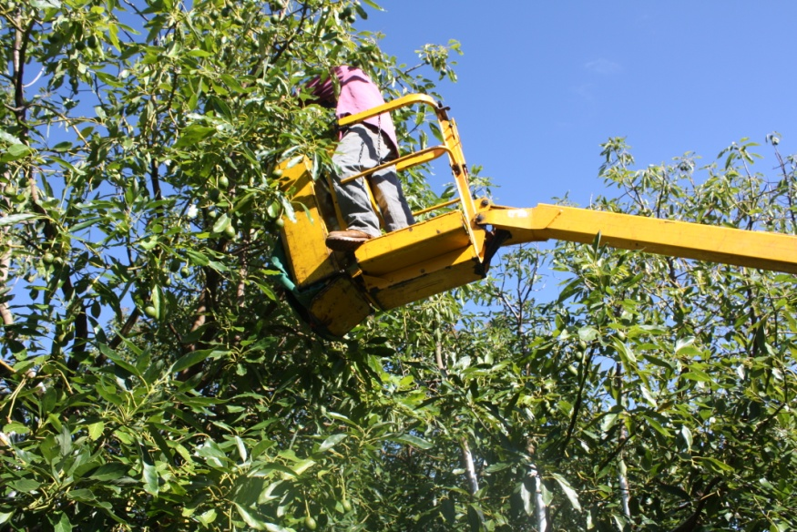

SAFETY INDUCTION
INFORMATION FOR PICKING
IN HORTICULTURAL INDUSTRIES

Worker:

Welcome to work on our farm. We hope that you find your work here interesting and rewarding. The health and safety of all the people who work and those who live the farm on this farm which we work on is the most important responsibility that we all share.

It is important that you understand our Work Health and Safety responsibilities. We want you to also understand the commitment that we as owners/ managers of this farm have made to ensure your health and safety and the health and safety of all others who may enter our farm.

Your safety is also your responsibility. If you feel that you cannot do a job safely, don’t do it. Let your supervisor know about the problem and we will work together to fix the problem or find a safe way to complete the job.

- HAZARDS ON THE FARM
Attached is a farm map. Marked on the farm map you will find hazards that we have identified, which may affect the work that you do on the farm, or may be particularly hazardous to your work. These include:
- Powerlines
- Dams, irrigation equipment and wet or boggy areas
- Dry Weather Only roads
- Other:

- WORK CLOTHES
You are expected to come to work dressed in suitable clothes, which do not pose a safety risk. These include:
- Suitable work boots with non-slip soles for work on the farm or packing shed.
- Jeans, trousers, overalls or sensible work shorts.
- Long sleeved shirt (preferably), buttoned at the wrist, or rolled up so that no loose ends can be caught in machinery or on protruding materials.
- Shirts tucked into trousers, and no loose clothing that could be caught in machinery, including corks of jackets etc.
- A wide brimmed hat for outdoors work.
- You are expected to wash your work clothes after each work day, especially when working with chemicals.
- Other:

- FOOD AND WATER
It is most important to make sure that you have plenty of clean drinking water during the workday, especially in hot weather.
- Have a large water bottle filled with cool drinking water each day.
- Surface and dam water on the farm is NOT suitable for drinking. It may be contaminated by pesticides or animal waste.
- Drinking water and water bottles can be filled at

- HYGIENE
Good personal hygiene will help to reduce the risk of illness due to infection or contamination with hazardous chemicals that you may be exposed.
- Ensure that you wash after work, after handling pesticides, dogs or other animals, especially before eating or smoking.
- Make sure that your work clothes are washed regularly. You will need to wash them daily if you’re working outdoors where pesticides are used. Never re-wear clothes that have not been washed and are contaminated with pesticides.
- DO NOT smoke inside buildings, farm vehicles or cabined machines.
- Keep up to date with your tetanus vaccinations.
- DO NOT be in possession of, consume or be suffering the effects of alcohol or any illicit/ illegal drug.
- Advise your manager of any medical condition that may affect your work or prescribed medications that you need to take in work time. This is most important if you need to take asthma medication.
- Other:

- PERSONAL PROTECTIVE EQUIPMENT (PPE)
Protective clothing and equipment is provided for your protection for some work. You must use these as instructed. Clean them properly after use and keep them in good order.
You must let your supervisor know if protective equipment is damaged, not available, or if you are having difficulty using the equipment provided. Protective equipment includes wearing or using:
- Ear muffs or plugs where noise is a problem
- A helmet for head protection when riding motorbikes and quads.
- Protective gloves, respirator and overalls when handling pesticides or when using chemicals.
- A facemask or respirator when dust is a problem and you suffer from asthma or other respiratory condition.
- Eye protection where insects and twigs may cause eye injury.
- Sunscreen when you are working outdoors in direct sunlight.

- FATIGUE
There are certain times of the year when we are very busy on this farm, especially during picking. At these times fatigue can affect the way we work.
- Take short breaks to reduce fatigue during these busy times. Fatigue increases the risk of accident and injury for operators of machinery as reflex times will be slowed and concentration lost.
- When working at night or long hours, it is especially important to be alert. Ensure that you get enough sleep and arrive at work fresh.
- Other:

- CHERRY PICKER OPERATION AND MAINTENANCE
Hazards relate to falls, the risk of electrocution, overloading, loss of control when operating the cherry picker on steep un-even ground, the cherry picker toppling when it is overloaded and the operator falling or being crushed.
- DO NOT use or operate a cherry picker without authorisation or being familiar with the Operator’s Manual, hazards and safety controls.
- DO NOT use or operate a cherry picker or any other machinery unless you have been trained and instructed in its safe use.
- DO NOT overload the cherry picker basket or operate it with more than one person in the basket.
- Before first using a cherry picker, at the start of the day you must complete a prestart safety check. This includes checking the level of fuel, oil, water, transmission/ hydraulic fluid; condition and operation of controls and safety/ emergency stop and the condition of tyres, brakes, brake locks, hinge pins and guards.
- You should report to the manager any malfunction or condition likely to affect the safe operation and not use any machine, which cannot be repaired before use. This includes guards that are damaged or missing, or where there are exposed moving parts of machines causing safety hazard.
- Slow down, lower the basket and drive slowly when turning or moving over rough or uneven ground.
- Keep the work platform clean of trash and fruit that may get caught under foot controls.
- Be aware of overhead powerlines which may cross avocado orchards - maintain at least a 3 metre distance from overhead powerlines. Use a trained safety observer when picking closer that 3 metres near or under overhead powerlines.
- Lower cherry picker baskets and follow safe transport routes that have been established to avoid powerlines.
- When leaving a machine with the engine running, you must ensure that equipment is disengaged, the machine is in PARK and the brake set.
- Whenever you remove a guard to undertake machinery maintenance, or to clear a blockage, you must replace that guard after finishing the repair and/ or before restarting the machine.
- Before working under machinery you must ensure that the machine is adequately blocked and supported.
- Other:

- TRACTOR AND MACHINERY OPERATION AND MAINTENANCE
- Do not operate any tractor, cherry picker, truck or fork lift unless you are properly licensed, trained, instructed and you have proper certification eg High Risk Work Licence where required.
- DO not ride unrestrained in vehicles or on the back of utes or on trailers.
- Before using any vehicle or machine for the first time each day, you must complete a safety check. This includes checking the level of fuel, oil, water, transmission fluid and the condition of tyres, brakes and guards.
- You should report to the manager any malfunction or condition likely to affect the safe operation of any machine, which cannot be repaired before use. This includes guards that are damaged or missing, or where there are exposed moving parts of machines causing safety hazard.
- When leaving a machine with the engine running, you must ensure that equipment is disengaged, the machine is in PARK and the handbrake set.
- Whenever you remove a guard to service, maintain, clean or to clear a blockage, you must replace that guard after finishing the repair and/ or before restarting the machine.
- Before working under machinery you must ensure that the machine is properly blocked and supported.
- Keep in mind the need to be aware of the location of overhead powerlines when operating and moving tall machinery.
- When operating any plant, machinery and forklifts, take care of and watch for other vehicles and pedestrian traffic.
- Make sure that any fold down Tractor Roll-Over Protective Structures (ROPS) are erected when leaving and using the tractor outside the orchard.
- Only use chainsaws, ladders and pruning equipment as instructed by your supervisor.
- Other:

- RIDING MOTORCYCLES AND QUADS
Motorbikes and quads contribute too many injuries on farm. You should:
- Wear suitable clothing including tough trousers and boots. A helmet should be worn for riding the farm motorcycle. Work or riding gloves may be needed.
- Before setting out at the beginning of the day, check fuel, check the tyres, guards and chain tension and check that the brakes are in good working order.
- Read the rider’s manual for any motorcycle that you ride.
- NO passengers or children are allowed to ride on quads.
- The speed limit for all vehicles on this farm is ……………km/h.
- Only ride the quads in areas that have been designated as safe.
- No Go areas on the farm are:
- Other:

- SNAKES
Snakes can be found in fields and orchards. They may also be found in and around long grass, irrigation equipment, dams and other cool areas. Many snakes are poisonous and many people are bitten by snakes when annoying, chasing or trying to kill snakes.
- If you come across a snake, move away quickly and let the snake move away. If other workers are nearby, let them know where the snake has gone.
- If bitten by a snake, place a firm pad over the bite, bandage securely and keep the limb as still as possible. Use the communication system to get help quickly.

- READY FOR EMERGENCIES
In the case of an emergency, assess any further danger, provide First Aid as required, and notify your supervisor or Dial Triple Zero - 000 for fire brigade, ambulance or police for further assistance.
- First Aid kits are located
- Trained and designated First Aid officer/s are:
- Emergency telephone numbers are located at the telephones at
- The UHF/VHF channel used on the farm is
- The bush fire brigade channel is
- Fire extinguishers are located
- Fire blankets are located
- The emergency evacuation and assembly point is

- INJURY REPORTING
We keep a farm Injury Register on this farm and would like any injury or illness that results from your work on this farm recorded in this register. We record all injuries/ illness whether minor or major.
- Notify the owner manager of all injury.
- You will find an Injury Register forms located at:

- GENERAL
The law requires that the Person Conducting and Business or Undertaking (PCBU) provides and maintains a safe workplace and safe work systems (training, instruction, information and supervision). Workers must follow all reasonable safety instructions given to them; work safely so they don’t injure themselves or other people at work.
Watch out for visitors and other people at the workplace, especially children who live on the farm.
To help us both meet these obligations, you are expected to advise the owner / manager of any safety hazard or problem that you come across.
- The law requires that the safety of visitors and contractors who enter this workplace be assured. You must look out for hazards to health and safety for family members, contractors and others who enter the farm.
- You are also required to cooperate with our health and safety program, and comply with our requirements to protect your own safety and the safety of others.
- There are children on this farm. Their safety must be a high priority. Please be careful when driving vehicles or machinery, never reversing without checking for children.
- Children are not permitted to ride on tractors or other farm machinery
- Children and passengers are not permitted to ride on quads
- Children are not allowed in the packing shed

The safety of people on this farm is our highest priority and takes precedence over everything else – especially when we are under pressure!

Signed: ______________________________________ Date: ___ / ___ / ___
Worker

Name: _______________________________________
Print

Signed: ______________________________________ Date: ___ / ___ / ___
Contractor

Name: _______________________________________
Print

DISCLAIMER
This document does not, in any way, excuse a person from doing all that is reasonable to ensure the health and safety of themselves and others. Legislative requirements vary between states and territories. Therefore, it is necessary to check with the relevant state or territory occupational health and safety authority for appropriate information.

