HEALTH AND SAFETY ON OUR FARM

WE SHARE RESPONSIBILITY
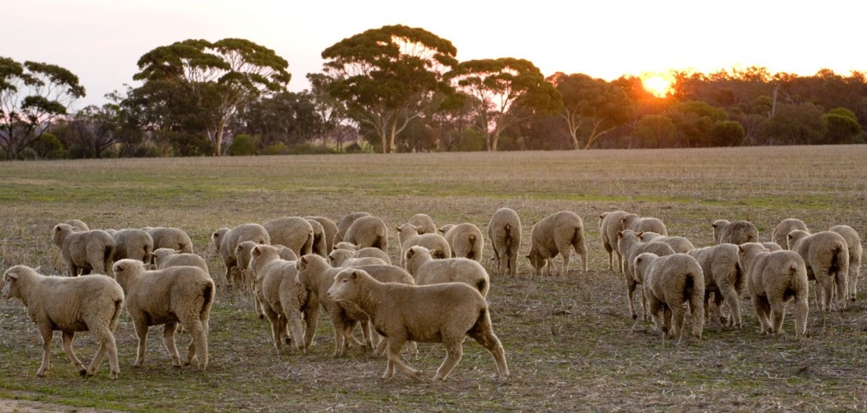

SAFETY INFORMATION
FOR WORKERS AND CONTRACTORS

Welcome to work on our farm. We hope that you find your work here interesting and rewarding.
The health and safety of all the people who work and who live on this farm is the most important responsibility that we all share.

It is important that you understand your work health and safety responsibilities. We want you to also understand the commitment that we as managers of this workplace have made to ensure your health and safety, and the health and safety of all others who enter this workplace.

Your safety is as much your responsibility as it is ours. If you feel that you cannot do a job safely, don’t do it. Let your supervisor or the farm manager know about the problem and we will work together to fix it, or find a safe way to complete the job.

Every workplace must have rules and guidelines to ensure that safe work practices are followed. This leaflet outlines some of the rules and guidelines that you are expected to follow on this farm. Please read this leaflet carefully and if you do not understand any section, please ask for an explanation.
- HAZARDS ON THE FARM
Attached is a farm map. Marked on the farm map you will find hazards that we have identified. These hazards may affect the work that you do on the farm, or may be particularly hazardous to your work. These include:
  - Power lines
  - Dams / bore drains / wet boggy areas
  - Electric fences / electric tape
  - Disused fences
  - Dry weather only roads
  - Restricted access / steep / rocky / cliffs / eroded /no-go areas
  - Other hazards:

- WORK CLOTHES
You are expected to come to work dressed in suitable clothes, which do not pose a safety risk. These include:
  - Suitable work boots with non-slip soles for work on the farm.
  - Work trousers, overalls or sensible work shorts.
  - Long sleeved shirt (preferably), buttoned at the wrist, or rolled up in such a way that no loose ends can be caught in machinery or on protruding materials.
  - Shirts tucked into trousers and no loose clothing that could be caught in machinery, including cords of jackets etc.
  - A wide brimmed hat and sunglasses for outdoors work.
  - Come to work in clean clothes; you are expected to wash your clothes after each work day, especially after using chemicals.
  - Other:

- HYGEINE AND HEALTH
Good personal hygiene will help to reduce the risk of illness and loss of work time due to infection or contamination with hazardous substances that you may be exposed to. You must:
  - Ensure that you wash up after working and after handling chemicals or dogs or other animals, especially before eating.
  - Wear clean clothes and make sure that your work clothes are washed regularly and separately.
  - You will need to wash clothes daily if you’re using pesticides / chemicals or working in areas that have been sprayed.
  - NOT smoke inside buildings, farm vehicles cabined machinery or near building entrances.
  - Keep up to date with your tetanus vaccinations.
  - Not be in possession of, consume or be suffering the effects of alcohol or any illicit drug.
  - Advise your manager of any prescribed medications that you need to take in work time. This is most important if you need to take asthma medication.
  - Shower or at least, wash face, arms and hands after spraying or using farm chemicals.

- USE OF PROTECTIVE CLOTHING AND EQUIPMENT
Protective clothing and equipment is provided for your protection for some hazardous tasks. You must use them as instructed, clean them properly after use and keep them in good order. You must let the manager know if protective equipment is damaged or not available, or if you are having difficulty in using the equipment provided. Protective equipment includes:
  - Ear muffs or ear plugs where noise is a problem.
  - A helmet for head protection when riding a horse, motorbike or quad.
  - Gloves and eye protection when using a motorbike or quad.
  - Protective gloves, respirator, overalls when handling pesticides and when working in contaminated areas.
  - A face mask or respirator when dust is a problem, or if you suffer from asthma or other respiratory condition.
  - Goggles and / or welding helmet, gloves and other protective clothing when welding.
  - Sunscreen, hat and sunglasses when you are working in outdoors.
  - Safety glasses or goggles when fencing, slashing, using brush cutters or grinding.

- ADEQUATE FOOD AND WATER
  - Before setting out each day you must ensure that you have adequate food and water to last for the day.
  - It is very important to make sure that you have plenty of clean cold water with you to drink (at least 5 litres) during the workday, especially in hot weather.
  - Surface water on the farm is NOT suitable for drinking. It may be contaminated with animal waste.
  - Other:

- FATIGUE AND WORKING ALONE
There are certain times of the year when we are very busy on this farm. At these times it is often necessary to work during the night.
  - You are encouraged to take frequent short breaks to reduce fatigue during these busy times. Being tired increases mistakes and increases the risk of injury for machinery operators as reflex times will be slower and concentration reduced.
  - When working during the night it is especially important to be alert.
  - Ensure your communication systems are working (mobile, UHF, personal locators - Emergency Position Indicating Radio Beacon - EPIRB).
  - Always let someone know where you are working on the farm and what time you are due back, including the route that you will take.
  - Do not get into dams, tanks or water; do not work in water alone.

- RIDING QUADS AND MOTORBIKES
You should:
  - Wear suitable clothing including tough trousers and boots.
  - A helmet must be worn when riding the farm motorbike or quad. Work or riding gloves may be needed.
  - A visor, safety goggles or glasses should be worn to prevent insects flying into eyes.
  - Before setting out at the beginning of the day, check fuel, tyres, oil, guards and chain tension. Check that the brakes are in good working order.
  - Read the rider’s manual for any quad or motorbike that you ride.
  - DO NOT CARRY passengers on the quad.
  - The speed limit for all vehicles on this farm is …………… km/h.
  - No operators under the age of 16 years old to ride the quad.

- USING CHEMICALS AND PESTICIDES
Pesticides that we may use on this farm include chemicals to kill or control insects, weeds, fungal disease, mice or rats, as well as fertilisers and fuel.
  - All persons handling and using chemicals (including pesticides) must follow the safety instructions detailed on the product label for mixing and using chemicals.
  - If you cannot read or understand the label instructions, you must ask for help before continuing.
  - Protective clothing and Personal Protective Equipment (PPE) must be worn as stated on the chemical label or Safety Data Sheet.
  - Always have sufficient water for washing yourself, and have access to clean clothes when using pesticides.
  - When you have finished spraying, pesticides should be locked away in the chemical storage area and information recorded in the Farm Chemical Register.
  - Safety Data Sheets (SDS) are available for any hazardous chemical used on the farm.
  - The Farm Chemical Register and SDS are located

- MACHINERY OPERATION AND MAINTENANCE
  - Before starting any machine you must do a safety check. This includes fuel, oil, coolant, transmission fluid; the condition of tyres, brakes, lights; checking that all guards are not damaged and are in place.
  - You should report to the manager any malfunction or condition likely to affect the safe operation of a machine that you cannot fix before being used. This includes guards that are damaged or missing and where there are exposed moving parts of machines causing a safety hazard.
  - All machinery and vehicles must be turned off and the key removed before maintenance, cleaning or clearing any blockages.
  - When leaving a machine with the engine running, you must ensure that equipment is disengaged and the gear shift is in neutral.
  - Whenever you remove a guard to undertake machinery maintenance, or to clear a blockage, you must replace that guard after finishing the repair and/or before restarting the machine.
  - Before working under machinery you must ensure that the machine is adequately blocked and supported.
  - Keep in mind the need to be aware of the location of overhead power lines when using and moving high machinery.
  - If a vehicle is fitted with a seatbelt - tractor, Side by Side, Ute, Bobcat etc, it must be worn.

- BORE AND WINDMILL MAINTENANCE
Before climbing or servicing a bore, make sure you have the proper training and instruction to do the job safely.
  - If a bore needs pulling, make sure you take someone with you who also knows how to do the job, and has experience.
  - Make sure you know where you are going - take a property map, and ask if you are not sure.
  - Before leaving on a bore run, check that you have all the tools and equipment to get the job done.
  - Check that you have a two way radio and/or mobile reception and that it is working.
  - Always pack water, a snack and lunch. A bore run may take all day.
  - In the case of vehicle breakdown, do not leave the vehicle.
  - If windmill maintenance is needed, you must do the job according to the specific safety instructions that you will be given. Do not ever climb if you are alone.
  - If you are afraid of heights tell someone and do not climb windmills.
  - Before climbing a mill, wear a safety harness and attach it to the ladder/ platform to hold you safely in case you slip or lose balance and fall.
  - Visually check that ladders are safe to climb and pull the windmill out of gear before climbing.
  - Do not start any work if it is too windy. If you are not sure, ask the boss.
  - Always check the mill fan / wheel is not directly above you before you climb onto the platform.
  - Wear a hard hat when standing underneath a mill when maintenance is being done. Be careful not to drop tools and parts onto workmates below.

11. MUSTERING
Good stock handling techniques will help keep sheep calm and reduce stress, both to the animal and stock handlers.
- Mustering needs to be planned. Allow enough time and follow directions given to you by your supervisor. If you are unsure or don’t understand, ask the boss again.
- When mustering by horse, side by side vehicle, motorbike or quad, wear a helmet and any other protective equipment needed and supplied.
- Always pack a suitable amount of water and food, mustering may take longer than planned.
- Make sure you have your hat and that you have skin protection.
- When assisting helicopters / planes or mustering on the ground, follow all directions given to you by the pilot.
- Stay clear of the helicopter until the pilot gives you a signal to approach.
- Approach and leave a helicopter only from the front where the pilot can see you, always be aware of the main rotor blades and tail rotor.
- When a passenger or observer is in an aircraft or helicopter, do not unbuckle your seat belt to exit until the pilot has given you the OK.
- Use of drones (in development)
- Other: ……………………………………………………………………………….

12. WORKING IN SHEEP YARDS
Before working in yards, you will be shown the layout of the yards and any safety features. Follow all directions given to you by your supervisor.
- The plan of work for the day and operation of yard equipment will be explained e.g. drafting and working race, cradle and dip etc.
- Handle stock calmly and quietly.
- When working with rams or wool blind sheep, you should take special care to avoid being butted.
- Dogs are used when necessary and should be kept away from the yard when not working.
- Other: ……………………………………………………………………………….

13. LOADING AND TRANSPORTING
Employees handling sheep can be seriously injured in loading races and falling from stock trucks and crates.
- When loading stock, do not get in front of sheep in loading races or in crates.
- Do not stand behind reversing trucks.
- To reduce the risk of injury from falling, do not get on top of the stock trucks and crates.
- Be aware of low overhead powerlines to prevent risk of electrocution.
- When loading wool, use lifting aids where practical.
- Other: ………………………………………………………………………………….

14. LIVESTOCK & GENERAL CARRIERS
- All drivers and operators must be wearing appropriate work boots.
- Drivers must contact the owner / manager on or before arrival to receive despatch or delivery instructions.
- Plan and allow sufficient time to reduce fatigue when driving long distances.
- High visibility vests are to be worn at night.
- If trucking livestock or delivering produce at night, ensure there is adequate light for loading / unloading.
- Ensure that trucks are fitted with reversing alarms.
- Truck drivers and others do not climb onto the top of stock crates without a fall prevention system in place.
- Only assist with loading or unloading if you are authorised by the farm owner or truck driver.
- Other: ………………………………………………………………………………………

15. SNAKES AND SPIDERS
Many poisonous insects, spiders and snakes are found on and around the farm, especially in long grass around dams, sheds and farm infrastructure.
  - If you come across a snake, move away and let the snake move away. If other workers are in the vicinity, let them know where the snake has gone.
  - If bitten by a snake, place a firm pad over the bite, bandage securely and keep the limb as still as possible. Use the communication system to get help quickly.
  - Other:

16. BEING READY FOR EMERGENCIES
  - In the case of an emergency call dial 000 for fire brigade, ambulance or police.
  - Before setting out each day always let someone know your planned location on the farm.
  - First Aid Kits are available at
  - Emergency telephone numbers are located at the telephones

- The people on this farm who are trained in first aid are:

- The emergency plan is located at
- We use UHF channel ………………………. for communication.

17. REPORTING INJURY, SERIOUS NEAR MISS AND INJURY MANAGEMENT
We keep a farm Injury Register on this farm and would like any injury or illness that results from your work on this farm recorded in this register. We record all injuries/ illness whether minor or major.
- Injury Register Forms are located
or contact the owner/ manager.
- Workers Compensation Forms are available for your use; please contact the owner/ manager to access these.
- If you are injured during the course of your work on this farm, we will ensure your injury is managed and assist your early to return to work. We will work with your Doctor and other health providers to find suitable duties for you if you are not able to perform your normal work.
- The person responsible for the return to work of injured workers on this farm is:

18. GENERAL
The law requires that:
- The owner / manager provide a safe workplace and safe work systems.
- Workers take care for the health and safety of people at the workplace.
To help us both meet these obligations, you are expected to advise the owner/ manager of any safety hazard or problem that you come across.
- The law requires that the safety of all people who work and enter this farm is managed. You must look out for hazards to health and safety for family members, contractors and visitors who enter the farm.
- You are also required to cooperate with our health and safety program, and comply with our requirements to protect your own safety and the safety of others.
- There are children on this farm. Their safety must be a high priority. Please be careful when driving vehicles or machinery, never reversing without checking for children.
- Children are not permitted to ride on tractors, quads or other farm machinery.
- Children are not permitted in yards.

Declaration:
I have read the work health and safety instructions in this leaflet, discussed them with the manager and understand and accept my responsibilities.

I agree to do what is required of me to ensure that the health and safety of all people is protected on this farm.

Signed: _______________________________ Date: ___ / ___ / ___
Worker

Name: ________________________________
Print

Signed: _______________________________ Date: ___ / ___ / ___
Owner/Manager

Name: ________________________________
Print

DISCLAIMER
This document does not, in any way, excuse a person from doing all that is reasonably practicable to ensure the health and safety of themselves and others. Legislative requirements vary between states and territories. Therefore, it is necessary to check with the relevant State or Territory Work Health and Safety Authority for appropriate information.

