HEALTH AND SAFETY ON

OUR COTTON FARM

“We share responsibility”

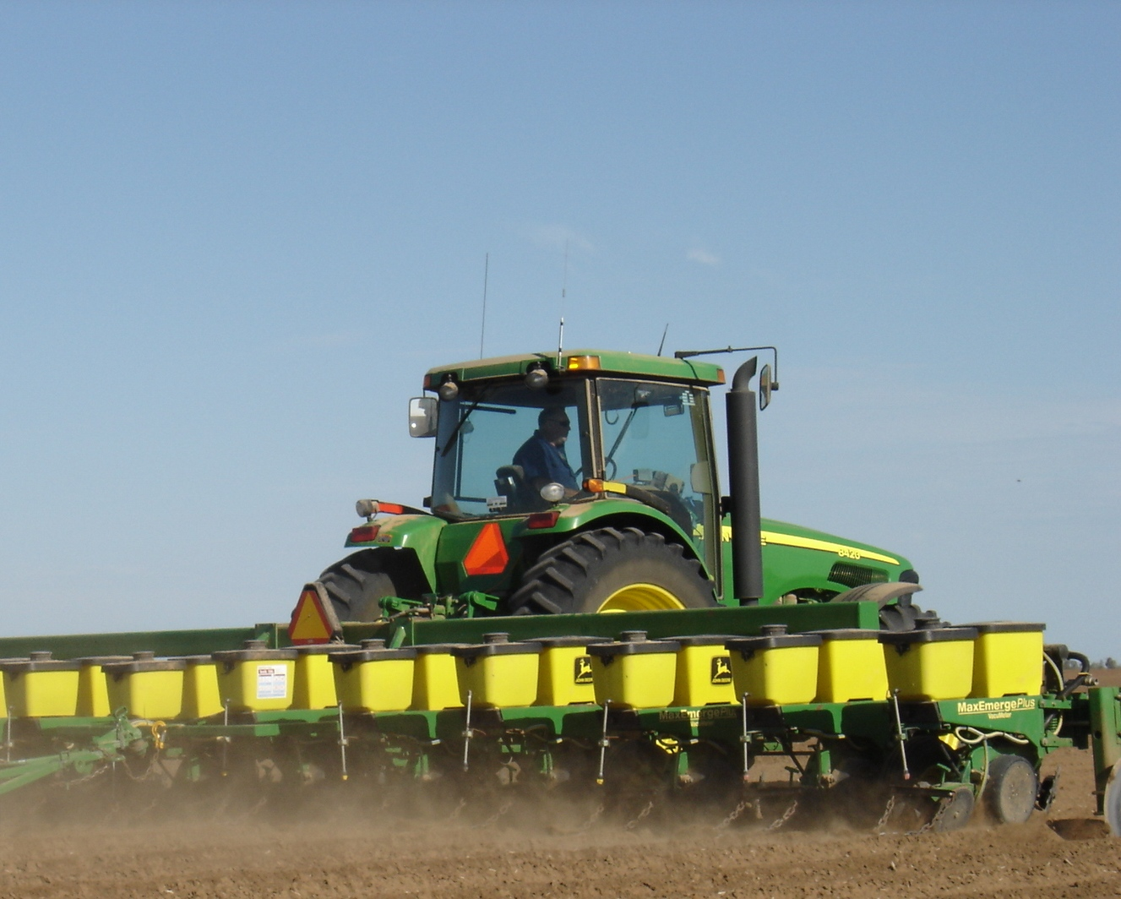

EMPLOYEE SAFETY INDUCTION & HANDBOOK

Property: Worker:

Welcome to work on our cotton farm. We hope that you find your work here interesting and rewarding. The health and safety of all the people who work and who live on this farm is the most important responsibility that we all share.
It is important that you understand your health and safety responsibilities. We want you to also understand the commitment that we as owners and managers of this workplace have made to ensure your health and safety, and the health and safety of all others who enter this workplace.
Your safety is as much your responsibility as it is ours. If you feel that you cannot do a job safely, don’t do it. Let your supervisor or the farm manager know about the problem, and we will work together to fix the problem or find a safe way to complete the job.
Every workplace must have rules and guidelines to ensure that safe work practices are followed. This leaflet outlines some of the rules and guidelines that you are expected to follow on this farm. Please read this leaflet carefully, and if you do not understand any section, please ask for an explanation.

INTRODUCTION TO WORK PLACE HEALTH SAFETY
The law requires that:
- The owner / manager provide a safe workplace and safe work systems.
- Workers take care for the health and safety of people at the workplace.
- To help us both meet these obligations, you are expected to advise the owner / manager of any safety hazard or problem that you come across.
- The law requires that the safety of visitors, contractors and other workers who enter this workplace is assured. You must look out for hazards to health and safety for family members and others who enter the farm, let us know.
- You are also required to cooperate and comply with our health and safety requirements to protect your own safety and the safety of others.
- Our farm embraces a WHS Policy that employees have the responsibility to follow

PCBU - Person Conducting Undertaking Business have responsibility for:
- Consulting with employees and contractors about WHS matters
- Providing a safe working environment
- Maintaining safe systems of work
- Providing relevant safety information, induction, training and supervision of workers
- Keeping relevant WHS records
- Protecting the health and safety of all other people who enter the workplace

Workers and contractors have responsibility for:
- Participating in regular farm safety inspections, hazard audit and risk assessment
- Complying with the WHS policies of the business and directions given relating to protecting the health and safety of people in the workplace
- Protecting the health and safety of themselves and others in the farm workplace
- Cooperating with the farm’s WHS requirements
- Reporting hazards that require attention to ensure the health and safety of people in the workplace
- Suggesting improved methods to control risk

XXXX

Work Health and Safety Policy

The health, safety and well-being of people working at XXXX is important and we will do all that is reasonably practicable to ensure that they are not injured at work.

We aim to have a farm that is free of hazards and injury where people enjoy life and work.

To help us achieve a safe workplace, we ask people working at XXXX to:
  - participate in our efforts to manage work health and safety
  - follow all safety instructions and to work safely so they are not injured or cause injury to other people
  - report all safety hazards and risks they identify, and
  - report all injury or near-miss incidents where a workers’ health or safety is at risk

Signed:

Date:

EMPLOYEE ENGAGEMENT IN WHS
It is essential that all employers are engaged with our WHS program. We hold regular health and safety meetings with all workers to consider and review health and safety practice in this business and resolve health and safety issues as they arise.

- Informal safety toolbox meetings are held where workers can raise health and safety issues with the farm manager.
- Our workers (employees and contractors) are made aware of these consultation arrangements during our safety induction.
- We will also work closely with workers to resolve in a timely manner, any issues or problems relating to health and safety. If an issue cannot be resolved, the company will consult with a relevant farmer industrial association.
- Other opportunities to identify a WHS issue include:
(For eg white board in office, note of time sheet)

……………………………………………………………………………………………………………………………………………………………………………………………………………………………………………………………………………………………………………………………………………………………………………………………………………………………………………..

TRAINING, INSTRUCTION AND SUPERVISION
Before performing any job or using any machinery/equipment, we will assess our employee’s skills to ensure that they can do the job safely.

- Workers must not operate a machine which they have not been trained or instructed to use e.g. High Risk Work License for forklifts.
- Employees will be supervised while training in the safe operation of all plant and machinery.
- All plant and machinery must be operated as directed by the manufacturer’s Operators Handbook or as described in Safe Work Statement.
- A record of all workplace training will be maintained in a Training Register located in the farm office.
- All employees will be given instruction for work and jobs to be done safely. If you do not understand any instruction or directions given to you, please ask for a clearer explanation or demonstration of work or jobs to be performed.
- All workers are required to follow instructions given to them by the farm manager. If you have not been trained or instructed to use machinery or equipment to carry out your work, do not use it.
- All new employees will be supervised until they can demonstrate that they can operate the machine or do the job safely.
- Your safety can be monitored and supervised using two way radios or mobile phones. We have considered the types of emergencies that may occur and have planned for them.
- When work is being done alone or at night, we will ensure that you have a two-way radio or mobile phone.

HAZARDS ON THE FARM
There are a number of hazards associated with working on cotton farms. It is important that all hazards are regularly monitored and reported. Hazards can be recorded and reported in the following ways (eg white board in shed, on time sheet, at tool box talks):
……………………………………………………………………………………………………………………………………………………………………………………………………………………………………………………………………………………………………………………………………………………………………………………………………………………………………………..
- An annual farm inspection is conducted each year and will involve all employees. This will be conducted using checklists for hazards such as tractors, slashers, mulchers, irrigation pumps, workshops, harvesting machinery, vehicles etc.
- The farm manager is responsible for managing the health and safety of all workers (contractors and employees). The results of the farm audits and control options will be considered by our workers at our safety meetings.
- Records of farm safety inspections and health and safety audits are kept

……………………………………………………………………………………………………………………………………………….

- Attached is a farm map. Marked on the farm map you will find hazards that we have identified, which may affect the work that you do on the farm, or may be particularly hazardous to your work. These include:
  - Powerlines
  - Channels
  - Dams
  - Wet areas
  - Dry weather only roads
  - Other:

WORK CLOTHES
You are expected to come to work dressed in suitable clothes, which do not pose a safety risk. These include:
- Suitable work boots with non-slip soles for work on the farm
- Work overalls, long leg trousers or sensible work shorts
- Long sleeved shirt (preferably), buttoned at the wrist, or rolled up in such a way that no loose ends can be caught in machinery or on protruding materials
- Shirts tucked into trousers, and no loose clothing that could be caught in machinery, including cords of jackets etc
- A wide brimmed hat for outdoor work
- You are expected to wash your work clothes after each work day, especially when working with chemicals.

HYGEINE
Good personal hygiene will help to reduce the risk of illness due to infection or contamination with hazardous chemicals that you may be exposed to. You must:
- Ensure that you wash up after working and after handling pesticides, dogs or other animals, especially before eating.
- Make sure that your work clothes are washed regularly. You will need to wash them daily if you’re working in areas that have been sprayed with pesticides. Never re-wear clothes that have been contaminated with pesticides.
- NOT smoke inside buildings, farm vehicles or cabined machines.
- Keep up to date with your tetanus vaccinations.
- Not be in possession of, consume or be suffering the effects of alcohol or any illicit drug.
- Advise your manager of any prescribed medications that you need to take in work time. This is most important if you need to take asthma medication.
- Other:

USE OF PROTECTIVE CLOTHING AND EQUIPMENT
Protective clothing and protective equipment is provided for your protection for some hazardous tasks. You must use these as instructed and keep them clean and in good order.
- You must let the manager know if protective equipment is damaged or not available, or if you are having difficulty in using the equipment provided. Protective equipment includes:
- Ear muffs or plugs where loud noise is a problem
- A helmet for head protection when riding a motorcycle/ quad.
- Protective gloves, respirator, overalls when handling pesticides, and when working in contaminated areas.
- A face mask or respirator when dust (including cotton dust) is a problem, or if you suffer from asthma or other respiratory condition.
- Welding helmet, gloves and other protective clothing when welding; or goggles when using oxyacetylene.
- Sunscreen when you are working outdoors in direct sunlight.

CHILDREN ON FARM
- There are children on this farm. Their safety must be a high priority. Please be careful when driving vehicles or machinery, never reversing without checking for children.
- Children are not permitted to ride on tractors or other farm machinery

ADEQUATE FOOD AND WATER
It is most important to make sure that you have plenty of clean water with you during the workday, especially in hot weather.
- Before setting out each day you must ensure that you have adequate food and water (at least 5 litres of water) to last the day.
- Surface water on the farm is NOT suitable for drinking. It may be contaminated by pesticide or animal waste.
- Water bottles can be filled at:
- Other:

FATIGUE
There are certain times of the year when we are very busy on this farm. At these times it is often necessary to work during the night.
- You are encouraged to take short breaks to reduce fatigue during these busy times. Fatigue increases the risk of accident and injury for operators of machinery as reflex times will be slowed and concentration lost.
- When working during the night it is especially important to be alert.
- Other:

ELECTRICAL SAFETY
All electrical installations and maintenance is performed by a licensed electrician. Residual Current Devices (RCDs) are fitted to all electrical power boards and are inspected and tested regularly.

All power extension cord sets and portable power tools are regularly checked for wear. A register of electrical inspections of RCDs and electrical tools in kept in the XXXX office.

CONFINED SPACE
No employee or contractor is to work in any confined space on the farm unless they are trained and supervised. Silos and pump wells on farms often constitute a confined space. All people working in a confined space must have a bystander present. A register of identified confined spaces and entry permits is maintained at the office.

- WORKING A HEIGHTS
There is a risk of serious injury from falling when working above ground height. No employee or contractor will work at height without ensuring that ladders, steps and handrails are safe or fall prevention/arrest harnesses are in place. These structures include, but are not limited to:
- Overhead fuel, water tanks and windmills.
- Buildings and roofs.
- High machinery - e.g. cherry pickers, trucks and trailers.
XXXX will ensure that:
- Employees working at height are made aware of the hazards and risk management procedures.
- Fall arrest or fall prevention harnesses are provided and used.
- Employees are instructed in the correct use of fall prevention or fall arrest harnesses.

- FIRE SAFETY – INCLUDE WORKSHOP/MACHINERY
Many aspects of the cotton farming environment can pose a fire risk. The mature cotton itself is highly flammable. Fire can also be caused by smoking, mechanical failure and self combustion.
- Strictly No Smoking on or near machinery, the workshop or fuel storage. Smoking is not permitted in the field or operating any machinery during picking.
- All employees are to remain alert for the sight or smell of smoke. Apply water immediately and notify the manager or supervisor as soon as possible.
- All employees are familiar with the CottonSafe note regarding fire safety and fire extinguishers
- There are fire extinguishers located in the workshop, chemical storage and key vehicles. Details are:

RIDING THE MOTORCYCLE / QUAD
You should:
- Wear suitable clothing including tough trousers and boots. A helmet should be worn for riding the farm motorcycle. Work or riding gloves may be needed.
- Before setting out at the beginning of the day, conduct a daily safety check; refuel, check the tyres, guards and chain tension and check that the brakes are in good working order.
- Read the rider’s manual for any motorcycle or quad that you ride.
- NO passengers are allowed on the quad.
- The speed limit for all vehicles on this farm is ……………km/h.

- VEHICLE SAFETY
- A maximum speed limit of 80 kmh will be adhered to unless otherwise sign posted.
- Seat belts must be worn at all times when travelling around the farm.
- Keep vehicle doors closed at all times.
- Drivers should stay on designated roads at all times and not take any unauthorised shortcuts.
- Wherever possible, avoid using black soil roads when wet.
- A speed limit of 20 kph is to be strictly observed near any machinery – i.e pickers, module presses, tractors, earthmoving equipment and module yard equipment.
- All mobile plant and other farm machinery has the right of way at all times.
- No unregistered vehicles are allowed on public roads without the necessary legal permits.
- No vehicles are allowed of the farm without the permission and supervision of management.
- Park vehicles well away from operating machinery, in particular earthmoving and construction equipment and sites.
- Designated car parks are to be used at all times – i.e. office, workshop and living quarters.

HANDLING CHEMICALS ON THE FARM
Pesticides that we may use on this farm include chemicals to kill or control insects, weed, fungal disease, mice or rats and fertiliser. Fuels are also hazardous chemicals.
- All persons handling pesticides must follow the instructions detailed on the label for mixing and applying pesticides.
- If you cannot read or understand the instructions, you must ask for help before continuing.
- Protective clothing and personal protective equipment must be worn as stated on the pesticide label.
- Always have sufficient water for washing yourself, and have access to clean clothes when using pesticides.
- When you have finished your pesticide job, the pesticide should be locked away in the chemical storage area and information recorded in the Farm Chemical Register.
- Safety Data Sheets (SDS) are available on request for all hazardous chemicals used on the farm.
- The Farm Chemical Register and SDS are located at:

MACHINERY OPERATION AND MAINTENANCE
- Before starting any machine you must undertake a safety check. This includes checking the condition/level of fuel, oil, water, transmission fluid, tyres, brakes and guards.
- You should report to the manager any malfunction or condition likely to affect the safe operation of the machine that you cannot repair before operation. This includes guards that are damaged or missing where there are exposed moving parts of machines causing safety hazard.
- Ensure all machinery activities are recorded in an appropriate manner
- When leaving a machine with the engine running, you must ensure that equipment is disengaged and the machine is in ‘park’.
- Whenever you remove a guard to undertake machinery maintenance, or to clear a blockage, you must replace that guard after finishing the repair and/or before restarting the machine.
- Before working under machinery you must ensure that the machine is adequately blocked and supported.
- Keep in mind the need to be aware of the location of overhead powerlines when using and moving tall machinery.

IRRIGATING
When irrigating you must follow the farm rules to ensure that you are not exposed to pesticides or other chemicals recently sprayed on the crop or channels, and that you reduce your risk of injury from manual handling:
- You should not enter a field that has been sprayed within the re-entry period for the pesticide that has been applied, unless you are wearing appropriate personal protective clothing. Check with the farm manager if you are unsure.
- You should wear suitable footwear to ensure that your feet are protected from stubble and other foreign material.
- Protective gloves are supplied if you are required to move irrigation pipes and syphons that are hot, or have been contaminated with pesticides. These must be worn.
- Methods of handling and moving irrigation pipes and syphons to reduce risk of back and other injury have been explained.

SNAKES, SPIDERS, BEES, TICKS AND SCORPIONS
Snakes can be found anywhere. They may also be found around irrigation pipes, syphons, pump sites, irrigation water channels and in cotton fields. Many snakes are poisonous.
- If you come across a snake move quickly away and let the snake move away. If other workers are in the vicinity, let them know where the snake has moved.
- If bitten by a snake, apply a ‘pressure immobilisation bandage’ over the bitten area, apply a second bandage commencing at the fingers or toes and wind up as far as possible, immobilise the limb with a splint, and keep the limb as still as possible. Use the communication system to get help urgently.
- If bitten by a red back spider, cold compress to relieve pain, do not bandage, observe for any signs of deterioration. Seek doctor advice for any further treatment.
- If bitten by a funnel web spider, same treatment as for snake bites: apply a ‘pressure immobilisation bandage’ over the bitten area. Use the communication system to get help urgently.
- If a tick has burrowed under the skin remove with fine tweezers by grasping behind the head and removing carefully by pulling straight out ensuring the entire body is removed. Seek doctor advice for any further treatment.
- For Bee’s or scorpion sting, Remove the stinger, cold compress to reduce pain and swelling. If onset of allergic reaction: apply pressure immobilisation bandage and call ambulance.

BEING READY FOR EMERGENCIES
- In the case of an emergency Dial Triple Zero 000 for ambulance, fire brigade or police.
- Before setting our each day always let someone know your planned location on the farm.
- Emergency telephone numbers are located at the telephones/ UHF radios located at:

- First Aid kits are available at:

- The people on this farm who are trained in First Aid are

- The emergency plan is located at
- We use UHF channel ………………………. for farm communication.

INJURY REPORTING
We keep a farm Injury Register on this farm. Any injury or illness that results from your work on this farm must be recorded in this register. We record all injuries / illness whether minor or major. You will find an Injury Register forms located at …………………………………………………………………………………… or contact the owner/ manager.
Work Health and Safety and Workers Compensation legislation, requires employers keep a record of work related injury (including contractors). In the event a serious injury or illness, a death or dangerous incident the appropriate Work Health and Safety Authority must be immediately notified.
In addition, Workers Compensation Insurers require employers to provide a record of the work related injury and notify Worker Compensation insurer within a 48 hour period of the accident.

The safety of people on this farm
takes precedence over all other considerations
– especially when we are under pressure!!

Declaration:
I have read the work health and safety instructions in this leaflet, discussed them with the manager and understand and accept my responsibilities.

I agree to do what is required of me to ensure that the health and safety of all people is protected on this farm.

Signed: _______________________________ Date: ___ / ___ / ___
Worker

Name: ________________________________
Print

Signed: _______________________________ Date: ___ / ___ / ___
Manager

Name: ________________________________
Print

DISCLAIMER
This document does not, in any way, excuse a person from doing all that is reasonable to ensure the health and safety of themselves and others. Legislative requirements vary between states and territories. Therefore, it is necessary to check with the relevant state or territory occupational health and safety authority for appropriate information.

