HEALTH AND SAFETY ON
OUR COTTON FARM – WE SHARE

RESPONSIBILITY

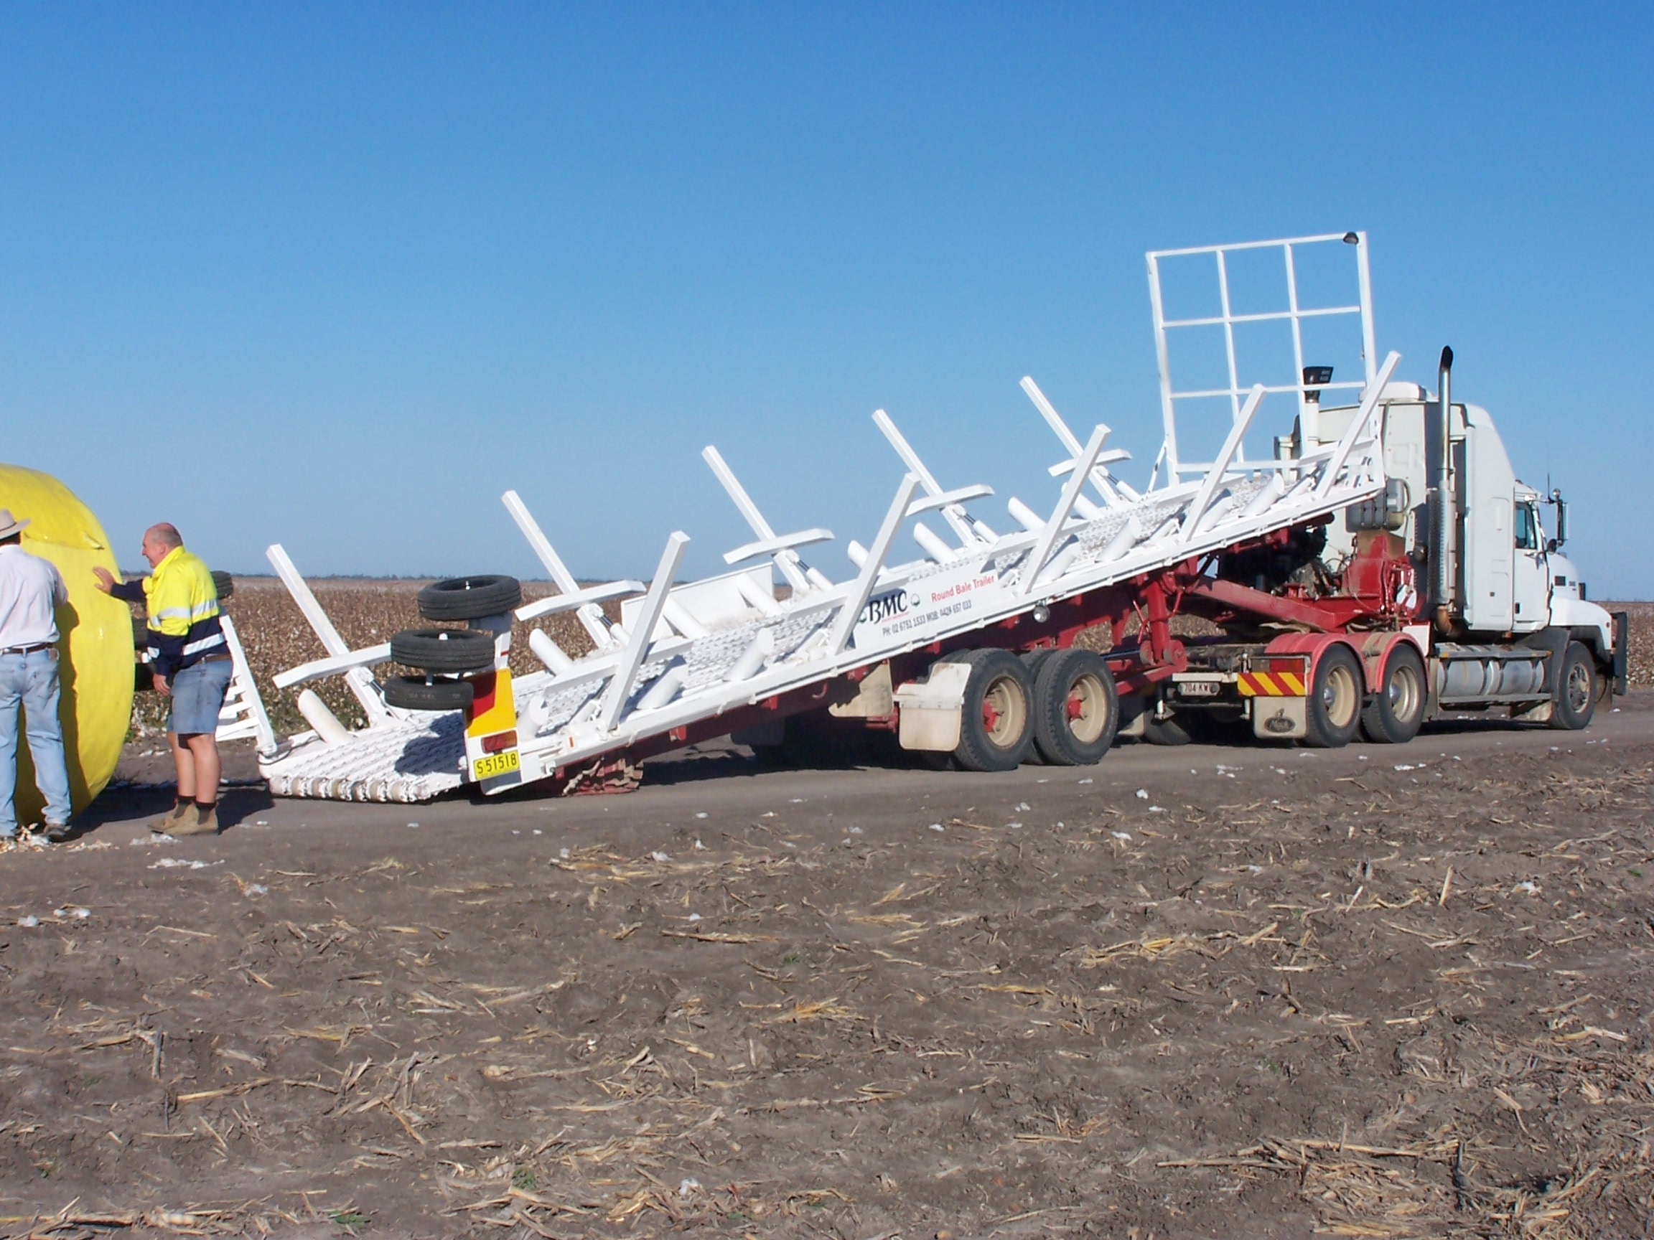

CONTRACTOR SAFETY INDUCTION

Includes cotton chipping, cotton picking, carting, spraying and agronomy.

Property: Contractor:

The health and safety of all the people who work and who live on this farm is the most important responsibility that we all share.

As owner/ manager, we have responsibility for the health and safety of workers and others who work on this farm. This includes contractors.

The following work arrangements are those that we see as important for ensuring the health and safety of all workers and visitors on this property.

Please read this leaflet carefully, and if you do not understand any section, please ask for an explanation. As the contractor, we ask you to include this information in safety information that you give to all workers in your team. Extra copies are available.

xxxx

Health and Safety Policy

The health, safety and well-being of people working for us is important and we will do all that is reasonably practicable to ensure that they are not injured at work.

We aim to have a business that is free of injury where people enjoy life and work.

To help us achieve a safe workplace, we ask people working for us to:
- participate in our efforts to manage work health and safety
- follow all safety instructions given and to work safely so they are not injured or cause injury to other people
- report all safety hazards and risks they identify, and
- report all injury or near-miss incidents where a persons health or safety is at risk.

Signed:

Date:

1. INTRODUCTION TO WORK PLACE HEALTH SAFETY
The law requires that:
- The owner / manager provide a safe workplace and safe work systems.
- Workers take care for the health and safety of people at the workplace.
- To help us both meet these obligations, you are expected to advise the owner / manager of any safety hazard or problem that you come across.
- The law requires that the safety of visitors, contractors and other workers who enter this workplace is assured. You must look out for hazards to health and safety for family members and others who enter the farm, let us know.
- You are also required to cooperate and comply with our health and safety requirements to protect your own safety and the safety of others.
- Our farm embraces a WHS Policy that employees and contractors have the responsibility to follow.

PCBU - Person Conducting Undertaking Business have responsibility for:

- Consulting with employees and contractors about WHS matters
- Providing a safe working environment
- Maintaining safe systems of work
- Providing relevant safety information, induction, training and supervision of workers
- Keeping relevant WHS records
- Protecting the health and safety of all other people who enter the workplace

Workers and contractors have responsibility for:

- Participating in identifying and reporting of hazards and reporting any injuries
- All workers are to follow safety directions given to them
- Protecting the health and safety of themselves and others in the farm workplace
- Cooperating with the farm’s WHS requirements
- Reporting hazards that require attention to ensure the health and safety of people in the workplace

REPORTING HAZARDS ON THE FARM
We have already made a check of this farm to identify hazards to workers and others, and we are working to continue to improve the working environment to prevent injury and illness.

- We ask that you report hazards that you and your workers notice, to the owner / manager, and we will welcome your suggestions for how to reduce the risk of injury / illness.

HAZARDS ON THE FARM
Attached is a farm map. Marked on the farm map you will find hazards that we have identified, which may affect the work that you do on the farm, or may be particularly hazardous to your operation. These include:
- Powerlines
- Channels
- Dams
- Wet areas
- Recently sprayed areas
- Proposed spray activity that may affect your work on this farm

ACCESS TO AREAS OF THE FARM
The tracks and roads on this farm are not made to public road standards. Vehicle speed should not exceed …………………………….km/h. When driving near buildings, speed should be reduced so that you can stop instantly to avoid injury to others.

The attached farm map outlined access roads and areas of this farm to which you and your workers will have access. Please let the owner/ manager know if any member of your team would like access to any other part of the farm, so that their safety and that of other is protected.

EMERGENCIES
In the case of an emergency, Dial Triple Zero 000 for fire brigade, ambulance or police.
First aid kits are located
Emergency telephone numbers are located at

The UHF/ VHF channel used on the farm is
The bush fire brigade channel is
Fire extinguishers are located
Fire blankets are located
Trained and designated first aid officer/s are

You are responsible for the provision of emergency equipment on your machinery e.g. fire extinguishers, where required.

COMMUNICATION SYSTEMS
Please supply your contact details to In case we need to contact you in an emergency.

If you need to contact the manager of this farm:
Name
Phone (daytime):
Phone (night time):
Phone (mobile):
Fax:
Email:

The people who are available to handle any questions that you have are:
Name:
Telephone:
Position:

WORK CLOTHES
Your workers are expected to come to work dressed in suitable clothes, which do not pose a safety risk. These include:
- Suitable work boots with non-slip soles for work on the farm
- Work overalls, long leg trousers or sensible work shorts
- Long sleeved shirt (preferably), buttoned at the wrist, or rolled up in such a way that no loose ends can be caught in machinery or on protruding materials
- Shirts tucked into trousers, and no loose clothing that could be caught in machinery, including corks of jackets etc
- A wide brimmed hat for outdoors work.
- Your workers are expected to wash their work clothes after each work day, especially when working with chemicals.

HYGEINE
Good personal hygiene will help to reduce the risk of illness due to infection or contamination with hazardous substances that your worker may be exposed to. Your workers must:
- Ensure that they wash up after working and after handling pesticides or dogs or other animals, especially before eating.
- Make sure that their work clothes are washed regularly. They will need to wash them daily if they’re working in areas that have been sprayed with pesticides. Never re-wear clothes that have been contaminated with pesticides.
- NOT smoke inside buildings, farm vehicles or cabined machines.
- Keep up to date with their tetanus vaccinations.
- Not be in possession of, consume or be suffering the effects of alcohol or any illicit drug.

PROVISION AND USE OF PERSONAL PROTECTIVE EQUIPMENT AND CLOTHING
It is your responsibility to provide Personal Protective Equipment (PPE) for your workers to perform their work. It is also your responsibility to ensure that your workers are dressed in appropriate work clothes and that they use the protective equipment that you have provided for their use.

The owner / manager will inform you of the areas of the farm the have been recently sprayed with pesticide. It is your responsibility to provide appropriate PPE for your workers if they are required to work in these recently sprayed areas. If you have any questions, please contact the farm owner/ manager.

AMENITIES
The following amenities have been made available for your use and the use of your workers:
- Toilets
- Shelter sheds
- Drinking water
- Washing facilities

WORKERS COMPENSATION ARRANGMENTS*

EITHER
You, the contractor are responsible for Workers Compensation insurance for the workers in your team. We need to see your current policy and record details.

OR
Your workers are covered for Workers Compensation by the policy of this farm. A copy of the policy is available for perusal.

(*Advice is available regarding who is responsible for Workers’ Compensation is available from your insurer, your state’s work health authority or your farmer organization).

INJURY REPORTING
We keep a farm Injury Register on this farm and you must report any serious incident, injury or illness.
You will find an Injury Register forms located at _____________________________________or contact the owner/ manager.
Work Health and Safety and Workers Compensation legislation, requires employers keep a record of work related injury (including contractors). In the event a serious injury or illness, a death or dangerous incident the appropriate Work Health and Safety Authority must be immediately notified.
In addition, Workers Compensation Insurers require employers to provide a record of the work related injury and notify Worker Compensation insurer within a 48 hour period of the accident.

GENERAL
If you feel that you, or your workers, do not have the resources or experience to undertake a job safely, please advise the owner/ manager, and do not proceed with the job.

The laws of this state require that the owner/ manager provide a safe place of work and safe work systems. In order to help us meet this responsibility, we ask you to tell the owner/ manager about any safety hazard or problem that you encounter.

The same law requires that all workers take care to ensure the health and safety of others who are on this workplace – including other workers, family and visitors.

We ask you and your worker to cooperate with our health and safety program, and comply with our rules to protect your own safety and the safety of others.

It is not acceptable for any worker to be under the influence of alcohol or other drugs during work on this farm. Any who is affected by alcohol or drugs will be asked to leave the farm until it is clear that no-one’s safety is at risk.
- There are children on this farm. Their safety must be a high priority. Please be careful when driving vehicles or machinery; never reverse without checking for children.
- Please do not bring children on to this farm.
- Please do not bring dogs on to this farm.

SPECIFIC INFORMATION

COTTON CHIPPING AND AGRONOMY CONTRACTORS
All cotton chipping and agronomy contractors who do work on this farm are expected to:
- Adhere to chemical re-entry periods when working in recently sprayed fields OR ensure that workers have access to, and wear, appropriate PPE if entering a field within the specified re-entry period.
- Be aware of, and make sure their workers are aware of, the systems of communication used on this farm (See 5. Communication Systems)
- Train their workers in, and adhere to, safe manual handling practices

COTTON PICKING CONTRACTORS
All cotton picking contractors who do work on this farm are expected to:
- Attend a Pre-picking meeting with all contractors involved in the picking process, to allow for planning and coordination of the teams involved.
- Be aware of, and make sure their workers are aware of, the systems of communication used on this farm (See 5. Communication Systems)

SPRAYING CONTRACTORS
All spray contractors who do work on this farm are expected to:
- Comply with requirements for chemical application records and supply a copy of those records to the owner/ manager
- Use chemical as per label instructions
- Use PPE according to label instructions
- Only use trained operators to apply chemical
- Report any safety incident relating to chemical use e.g. spills
- Use only the specified site for mixing/ loading and wash down. This site is located at

- Have Safety Data Sheets available for all chemicals that they use as part of their work

The safety of people on this farm takes precedence over all other considerations

Signed: ____________________________ Date: ___ / ___ / ___
Contractor

Name: _____________________________
Print

Signed: ____________________________ Date: ___ / ___ / ___
Owner / Manager

Name: _____________________________
Print

DISCLAIMER
This document does not, in any way, excuse a person from doing all that is reasonable to ensure the health and safety of themselves and others. Legislative requirements vary between states and territories. Therefore, it is necessary to check with the relevant state or territory occupational health and safety authority for appropriate information.

